:Create Certificate Authority (CA)
We create a CA with the command -newca (and we set a password). Then, we use -newreq for requesting the certificate and -sign for signing it

- Using this CA - create certificate for the Apache Server

We create a separate folder in lab—ssl called Apache, we move here the key and certificate, and request.

After that, we access the Apache folder, where inside the mods-enabled folder we can change some parameters in ssl.conf file
We add this lines:

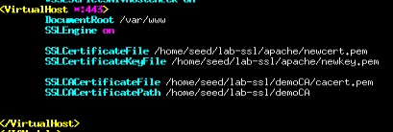
and we restart it with the initial password we gave while creating the CA

- Run Apache server with SSL enabled (accessible by https://localhost/

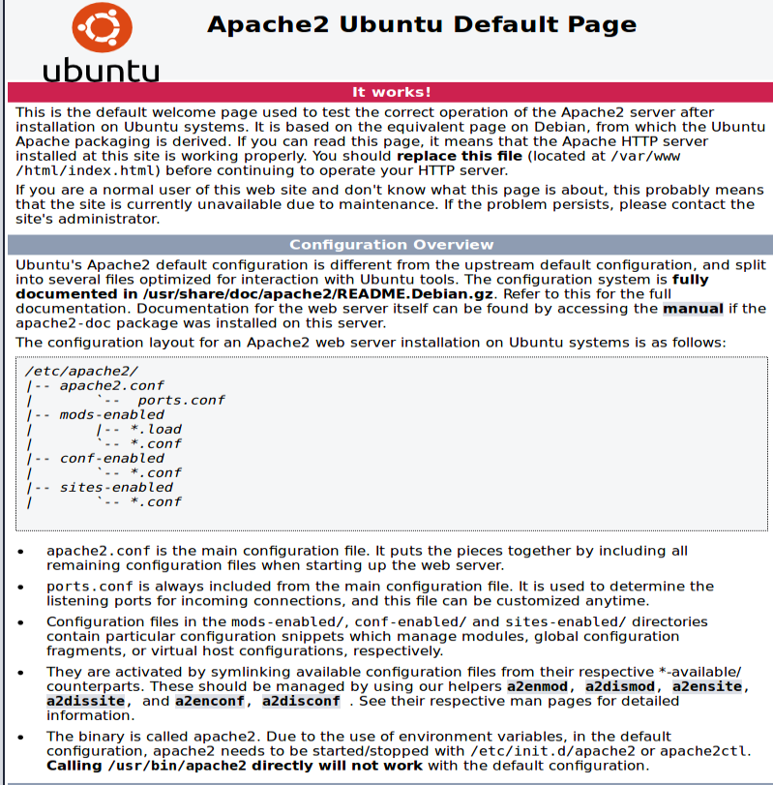
Apache server accessed! It works!

Part 2:
- Using CA -- create 2 or 3 certificates for different users

We request and sign 3 new certificates and then we store them in a distinct folder

- Import client certificate in Firefox
We merge the key and the certificate, and we export it under a pkcs12 file
In firefox, we import them in the Certificate Manager in the preferences
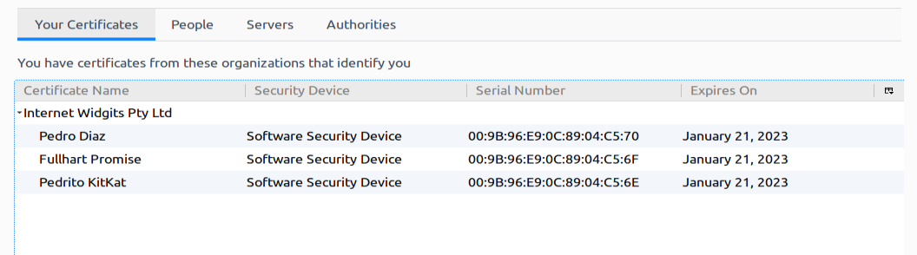
(It doesn't appear with the changed openssl.conf even though I changed all the information as you explained, might be because of some bugs)
- Configure Apache to accept access to a certain WWW page based on client certificate

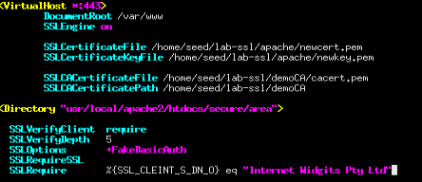
We add this in the apache2 ssl congifuration file

- Test if it really works

Sadly, it didn't for me :-(.

